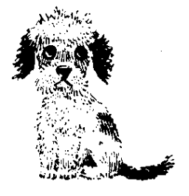

Animal Rescue Cumbria

(The Wainwright Shelter) CIO

Kapellan, Grayrigg, Kendal, Cumbria. LA8 9BS
Telephone 01539 824293

A Registered Charity No 1153737

DATE ……………………….

I, Mr/Mrs/Miss/Ms (full name)………………………………………………………………..

ADDRESS …………………………………………………………………………………….

…………………………………………………………………………………………………..

POST CODE: %POSTCODE% TELEPHONE …………………………………

EMAIL ADDRESS…………………………………………………………………………………..

Am taking the dog / cat named ………………………………………………………….

From Animal Rescue Cumbria – The Wainwright Shelter.

I realise that this animal is now my responsibility and I undertake to provide a good home and whenever necessary, veterinary care. I also agree:

- That an authorised member of Animal Rescue be allowed to visit the animal, at a reasonable time, to ensure he/she is healthy and happy in his/her new home.

- That if it is ever necessary to rehome the animal, I will contact Animal Rescue Cumbria at the Wainwright Shelter before any decision is made.

- That the animal will be neutered if not already done so, at the correct time unless for veterinary reasons this is not possible and also annual vaccinations are kept up to date. Checks will be made with your veterinary practice.

- To allow Animal Rescue Cumbria to reclaim the animal if in our opinion the terms are not being reasonably adhered to.

(As a registered charity, we are not allowed to sell animals but we rely upon donations to help us with our work. Any contributions will be gratefully received.)

SIGNED ……………………………………..

WITNESSED ON BEHALF OF ANIMAL RESCUE CUMBRIA ………………………...
___________________________________________________________________

OFFICE INFO:RECEIPT NO …………... CASH / CHQ / CARD GIFT AID YES/NO

ID CHECKED PHOTO YES/NO ADDRESS YES/NO

